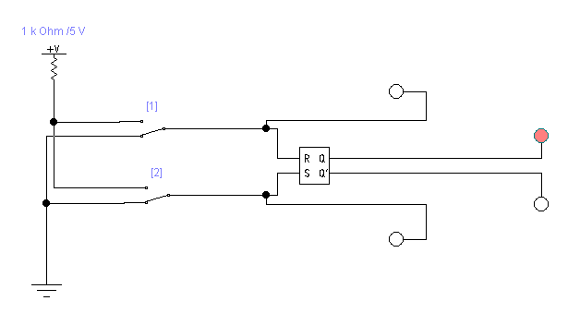

|  |  |  |  |  |
| --- | --- | --- | --- | --- |
| R | 0 | 0 | 1 | 1 |
| S | 0 | 1 | 0 | 1 |
| Q | 1 | 1 | 0 | 0 |
| Q’ | 0 | 0 | 1 | 0 |

5.18

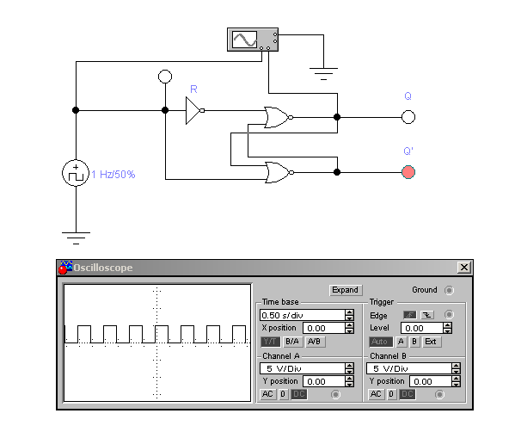

5.21