**INTRODACTION**

Laboratory works include all questions, which are considered in “Microwave electronic and quantum devices” lectures.

Procedure of laboratory works helps to student to master all knowledges, which were received during lectures, to get practical skills using microwave electronic and quantum devices.

During execution of laboratory works student must learn how to estimate experimental results using theoretical information on practice. And find reasons of disparity between experimental data and theoretical fundamentals.

Main condition of high efficiency of laboratory classes is execution of experiments and deep understanding of physical processes, which take place in microwave electronic and quantum devices.

Laboratory works executed after studying of theory of discipline.

Before execution of laboratory work student have to read this description and answer theory questions. To simplify preparation to the laboratory works there are list of self-checking questions.

Before execution of laboratory work teacher have to interview students to see if they are ready to execute the laboratory work.

During execution of laboratory work it is necessary to fallow all the rules of accident prevention.

During execution of reports, graphs must be drawn in an accurate manner and on the plotting paper, so experimentally received results can be simply recognized. If during measuring there are some errors appear, student should approximate and draw curves using experimental points according to theoretical material.

In the conclusion it is necessary to explain obtained curves, critically estimate experimental results and theoretical statements.

|  |  |  |
| --- | --- | --- |
| **Lab#** | **List of Laboratory works** | **Page#** |
| **1** |  |  |
| **2** |  |  |
| **3** |  |  |
| **4** |  |  |
| **5** |  |  |
| **6** |  |  |
| **7** |  |  |
|  |  |  |

**LABORATORY WORK #1**

**INVESTIGATION OF THE GENERATOR ON METAL-CERAMIC DISK TUBE**

**PURPOSE:**

1. To learn peculiarities of principal scheme and construction of oscillatory circuit of generators on metal-ceramic disk tube (MCDT)
2. To obtain practical skills in tuning of scheme and choosing MCDT operation mode.

Short theoretical information

On microwave tube working quality is decreasing and on a certain frequencies its usage is impossible. Decreasing of working quality may be caused by next reasons:

* Influence of interelectrode capacitance tube, that causes self-exciting or parasitic oscillations;
* The value of input and output capacitance of tube become comparable with resonance circuit capacitance. Interelectrode capacitance with wiring capacitance determine minimal permissible value of resonance circuit capacity, that leads to decreasing of characteristical resistance of resonance circuit, its Q-factor and stage efficiency;
* Increasing of power losses in dielectric of tubes and radiation losses in resonance circuit, and surrface effect, which decrease Q-factor and its equivalent resistance;
* On frequencies 500…1000 MHz tube electric inertia appears. It means that transit time of electrons between electrodes tube cathode and anode t<0.1T can be neglected. If transit time of electrons is equal to t≥0.1T we should pay attention on tube electric inertia. If t≥0.25T, we can not use tube static characteristics for mode operation calculations.

Tube inertia causes increasing of power excitation, changes pulse form of anode current, first harmonic amplitude of anode current *Ia1* in pulse decreases, so we have phase shift between voltage excitation *Uc* and *In1*. During positive voltage time some part of electrons can not transfer to anode so it returnes to cathode and heat it.

Thus, when we use tube power amplifier on higher frequencies, gain factor, efficiency and useful power decreases, at the same time, tube is heated up and tube autogenerator has lower frequency stability.

Boundary operation frequency of generator tube, in microwave, sometimes is limited by value of interelectrode capacitances and inductances of electrodes leads. Taking into account this parameters, equivalent scheme of triode generator looks like in a Fig.1.1,a.

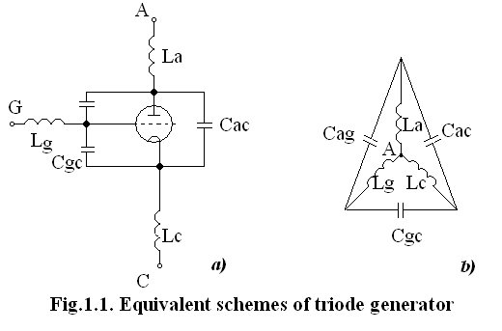

***a)*** **inductances of leads and interelectrode tube capacitance on microwave;**

***b)* inductances interconnection by “star”.**

Boundary generation frequency can’t be higher than own frequency of equivalent resonance circuit (RC) (Fig.1.1,b), which is obtained by interconnection of valve leads by “star”.

Output inductances and interelectrode capacitances cause additional power losses.

In microwave there are decimeter and centimeter waves, which use special MCDT with cylindrical electrodes.

Peculiarities of such tubes are: short electrode leads; disk-like control grid and ring or cylinder form of grid lead; cylindrical cathode and anode, operation surfaces – cylinder face; anode and cathode leads are located in a opposite sides of tube; small electrode volume, which diminishes interelectrode capacitances; small distances between electrodes, that diminishes electron transit-time; high anode voltage; high-efficiency active cathode with non-direct filament, that is necessary for receiving desired power with a small cathode volume; ceramic body (special radio-frequency ceramic); minimal ceramic volume; absence of other insulator inside a valve.

MCDT construction is specially designed for using in amplifiers, which are working in a scheme with common grid (CG). Usually, these tubes, triodes and tetrodes are used with the oscillatory circuits segments of coaxial cavity. (Fig.1.2,a)

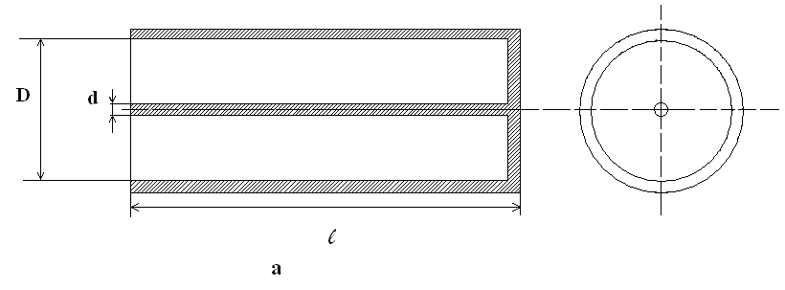

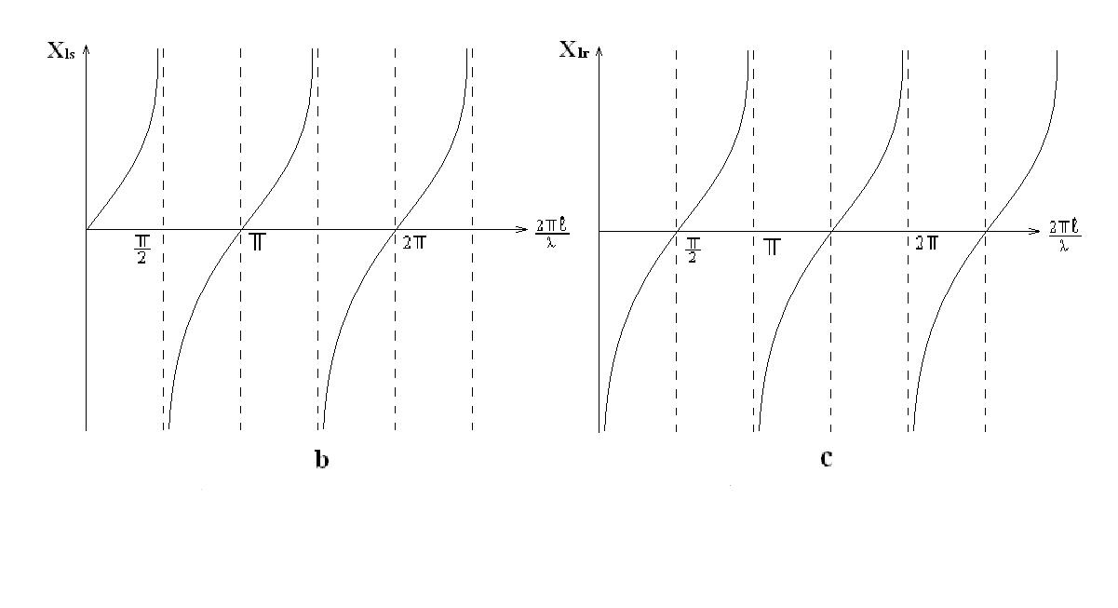

**Fig.1.2. Cavity resonator (a) and graphs that shows changing of reactive component of input resistance opened (b) and shorted circuit-end lines (c)**

Reactive component of input resistance of long line, open circuit-end (fig.1.2.b), $X_{o}=j{∙Z}_{c}∙tg(\frac{2π}{τ})$, and short circuit-end $X_{c}=- j{∙Z}_{c}∙tg(\frac{2π}{τ})$*.* Short circuit-endline is equivalent to parallel resonance circuit in resonance for $l=0.25τ+n∙0.5τ$, where n = 0, 1, 2, 3,…, and open circuit-end is equivalent to series resonance circuit in resonance for $l=0.5τ+n∙0.5τ$. Wave resistance of cavity resonator: $Z_{c}=138∙\lg{(\frac{D}{d})}$ (see fig.1.2.a). To avoid using connection wires between MCDT electrodes and contourresonatorelements of generator designed with cavity resonatorbothin input and output circuits. There are two types of dual-cavitygenerators: two-side (fig.1.3.a) and one-side (fig.1.3.b) location of cavity.

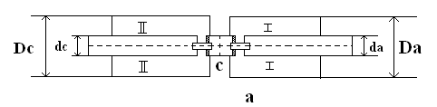

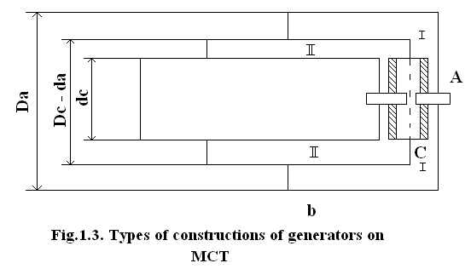

Resonator diameters *D* and *d* are chosen in such way - resonators must be connected with appropriate electrode tube leads (fig.1.3.b). To avoid appearing of high frequency waves**,** it is necessary execute condition $\left(D-d\right)< τ/4$. Resonators and other components are made from cuprum, brass and bronze**.**

To tune resonator in a wide boundaries we must change length of resonator *L*. For this purposes shortedwall of cavity resonator is made look-like a piston**.**

**Work procedure**

1. Learn oscillation system construction of the generator on MCDT ГИ-25. To get knowledges in construction and tuning of cavity system, feedback and loads. Complete electrical principle scheme of generator.
2. Turn on tube filament of generator.

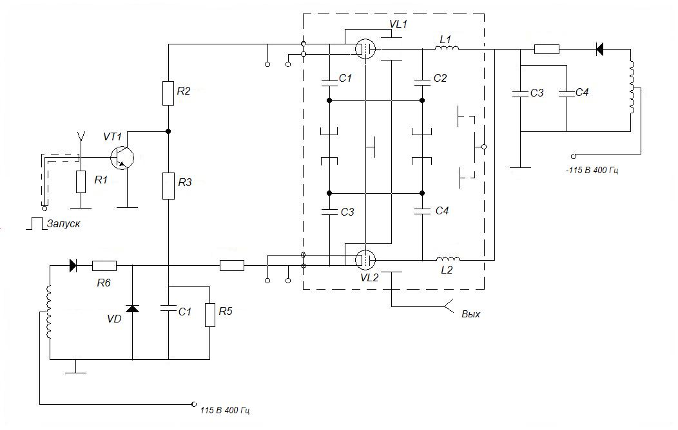

**Fig.1.4. Principle scheme of microwave generator on MCDT**

**Note.** Anode voltage is turning on after tube heating during 15-20 minutes.

1. After tube heating turn on anode voltage, feed on from pulse generator, which gives positive polarity pulses with 3V amplitude, 0.8….4μsec duration and frequency10KHz.
2. For investigation of graduated curve we must change tunings of anode cavity resonator in a range $0°…..270°$ through every 15° of a scale. Put results in a table 1.1.

**Table 1.1**.

|  |  |
| --- | --- |
| Resonator Tuning Scale, α° | Oscillation Frequency, *f* MHz |
|  |  |

1. Investigate frequency dependence as $f= φ\left(α°\right)$ and $I= φ_{1}(α°)$. Tune up generator in a certain frequency, to full-fill it we can use graduate curve which we previously obtain in the (p.4). Anode cavity resonator of generator must be out of the tune respectively to resonance frequency in a side of higher or lower frequencies, to obtain dependences which were written above (out of tuning should be executed in a minimal connection with load). Put the results to the table 1.2.

**Table 1.2**

|  |  |  |
| --- | --- | --- |
| Resonator Scale Factor, *α*° | Direct Current component $I_{a0}$, A | Oscillation Frequency, *f* MHz |
|  |  |  |

Report content

1. Purpose of the work.
2. Drawings of oscillation system.
3. Electrical circuit of generator.
4. Tables and graphs of investigated dependences.
5. Conclusions.

Self-checking questions

1. Name types of oscillation systems, which microwave generators use.
2. What are generator self-exciting conditions?
3. Name reasons of changing for the worse tube work on microwave with frequency increasing.
4. Name construction peculiarities of MCDT.
5. Explain properties of opened and shorted circuit-end lines.

**LABORATORY WORK #2**

**INVESTIGATION OF THE KLYSTRON GENERATOR**

**PURPOSE:**

1. Practical learning of controlling regime types of reflex klystron (RK).
2. Measuring of RK frequency and power in the centimetric band.

Short theoretical information

Reflex klystron is widely used as low frequency self-generator (from miliwatts to watts), of centimetric, partially milimetric bands, as heterodyne receivers of centimetric waves, scanning searching receiver, laboratory equipment of transmitter.

The main positive peculiarities of RK are: simple tuning, frequency regulation comparatively low feed voltage and small size.

Disadvantages of RK are: small electron tuning band, low efficiency. Work principle of RK is based on dynamic control of electron beam. It is one-cavity auto-oscillator, which functions are bunching and catching of electrons.

Electron flux that is emitted by cathode *K*, focused by special electrode *F* in a beam shape and moves under accelerating field of resonator. (fig.2.1).

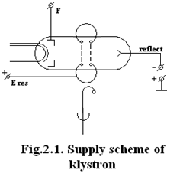After moving through cavity resonator grids, due existingof alternative voltage between resonator grids, velocity modulation of electrons is appeared. Electron beam gets reflector decelerating field *B*, loose velocity, move back in bunching form, then attracted by cavity resonator field and create current in this circuit. In reflector circuit there is no current. If we set time on X-axis (fig. 2.2), and distance from resonator to reflector $l$ on Y-axis, then curve that describe electron way will be parabola. After switching on power supplier, initial electromagnetic oscillations take place in cavity resonator. Electrons, which comes through resonator grid, is accelerated or is decelerated by its alternative field that is between grids (constant field between grids is absent). Electrons come from resonator with different velocities and in such way go away from resonator on different distances. As result (fig.2.2) we have next phenomenon – velocity modulation which transfers into density modulation. We also have bunching electrons, which comes back to resonator in different time periods and interaction with resonator field.

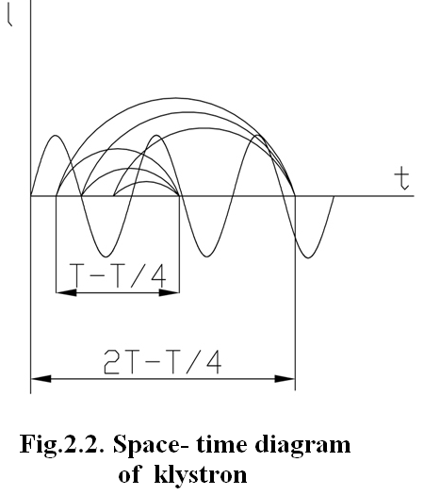If such bunched electrons interact with resonator grids in moments, when alternating field between grids will be decelerated - energy of alternating EM field will be added. For transferring kinetic energy process become more effective it is necessary that electrons come to resonator in that time periods, when slowing field is maximum of negative half-period. It can be executed by defined correlation between remaining time of electron in grouping space between resonator and reflector. Correlation between transit time *t0* and microwave period *T* is:

$t_{0}=\left(N-0.25\right)T$, N=1;2;3…

According to this reason transit angle in grouping field will be:

$ω_{0}=2πt_{0}$, $T=2π\left(N-0.25\right)T$

So, acceptable phasing conditions can be executed using $N$ (different generation zones) and different electron trajectories in grouping field. Time of remaining electron trajectories in grouping space can be regulated, by changing reflector voltage. In that time we have possibility to change oscillation frequency by changing reflector voltage supply (Fig2.2). The less reflector modulo voltage $E_{ref}$ the more oscillated frequency and vice versa. This method is called frequency tuning method. In common cause we have so called zone power character. Maximum oscillating power is not corresponds to first zone (zones numeration starts from maximum reflector voltage). Dependence of relative changing of its self frequency oscillations from reflector voltage:

$$\frac{Δf}{f_{0}}=(π\left(N-0.25\right))/Q(\frac{ΔE_{ref}}{E_{res}-E_{ref}})$$

Electron tuning slope:

$$\frac{Δf}{ΔE_{ref}}=-\frac{πf_{0}\left(N-0.25\right)}{Q\left(E_{res}-E_{ref}\right)}$$

This expression show how slope of electron tuning increase by increasing number of generation zone. Range of electron tuning are very small. Except that, mechanical frequency tuning is also used. It allows to change frequency in wider range and executed with a help of resonator mechanical deformation (with a changing of the distance between the grids).

Mechanical RK frequency tuning has inertiality, so needs big time interval. Electron efficiency of RK in first approaching can be determined as:

$$η=0.22/(N-0.25)$$

This formula doesn’t include oscillation system energy losses. In practice, RK efficiency is very small (tenth parts of percent). Parameters of some RK’s are in table 2.2.

Work procedure

1. Define average velocity of electron which get on first cavity resonator grid $ϑ≈6∙{10}^{7}\sqrt{E_{res}}$. If distance between resonator grids is $l=0.25mm$, and distance between resonator grid and reflector is $l_{r}=24mm$.
2. Find ratio of electron and light velocity:
$$\frac{ϑ}{c}≈\sqrt{E_{res}}/505$$

3. Define wavelength: $λ≈\frac{c}{f}$ using measured frequency $f$.
4. Calculate transit angle of intergrid clearance of resonator:
$$θ=ωl_{r}/ϑ$$

5. Define transit time: $τ=Q/ω$.
6. Define oscillation period: $T=1/f$
7. For given by teacher zone ( N = 1;2;3;…) calculate optimal bunched time: $t_{opt}=T\left(N-0.25\right)$
8. Define interaction coefficient of electron beam and clearance field:

$β=\frac{\sin{\frac{θ}{2}}}{\frac{θ}{2}}$.

1. Calculate optimal reflector voltage for several generation zones:
$$E_{ref}=\left(\frac{fl_{ref}\sqrt{E_{res}}}{1.5}∙{10}^{6}\left(N-0.25\right)\right)-E_{res}$$

2. Acquainted with laboratory stand and measurement devices. Draw feeding scheme of microwave klystron generator and space-time diagram (fig.2.1, 2.2).
3. Acquainted with maintenance of device ГК 4-19А instruction, learn methodology of microwave power and frequency measuring. Turn device on and calibrate it.
4. Turn power supply on. Set voltage $E_{res}=250V$, then find optimal reflector voltage for several generation zones. Put results into the table 2.1.

**Table2.1**

|  |  |  |  |  |  |
| --- | --- | --- | --- | --- | --- |
| Zone number | 1 | 2 | 3 | 4 | 5 |
| $$E_{ref opt}, V$$ |  |  |  |  |  |
| $$E_{ref calc,} V$$ |  |  |  |  |  |

1. Put obtained results (p.1…9) into the table 2.1 $E_{ref calc }$.
2. For given number of generation zone take dependence of $f=φ(E_{ref})$, complete table 2.2 and draw a graph of electron frequency tuning.
3. For given at p.13 generation zone define bands of frequency tuning. Put results into the table 2.2.

**Table2.2**

|  |  |  |  |  |  |
| --- | --- | --- | --- | --- | --- |
| $$E_{ref,} V$$ |  |  |  |  |  |
| *f*, GHz |  |  |  |  |  |

1. Measure maximum oscillation power and find electron efficiency of RK for first generation zone.

Report Content

1. Purpose of the work.
2. Functional scheme of laboratory arrangement.
3. Data (tables, graphs, calculations)
4. Conclusions.

Self-checking questions

1. Why does transit angle in generator triode decrease it work, but in RK it is necessary?
2. Which transit angle is bigger: between resonator grids or drift space?
3. What functions of RK resonator are?
4. Explain bunched electron process with a help of the graph.
5. What is generation zone?
6. How does mechanical frequency tuning is fulfilled and what ranges it has?
7. How generation frequency changes with reflector voltage increasing?
8. Name applications of RK.

**LABORATORY WORK #3**

**INVESTIGATING OF THE MICROWAVE GENERATOR ON BACKWARD WAVE TUBE**

**PURPOSE:**

1. To learn operation principle of the Backward Wave Tube (BWT)
2. To investigate characteristics of the BWT

**THEORY**

For klystron-type devices, in which energy transformation realizes in cavity resonators, we can name two main peculiarities:

1. Frequency bandwidth is determined by Q-factor;
2. Interaction of electrons with EMW fields in resonators has “one time” character in order of EMW cycle: electrons are decelerated by reflector field and give energy to cavity resonator during one half-period of resonator oscillations.

BWT’s operation principle is based on long interaction of electron beam with EMW in resonance system (slowing system). This continuous interaction appears by correspondence of electron and EMW transmission velocities.

But electrons in free space can not move with the velocity close to EMW velocity, due to Einstein relative theory there some relativistic effects are, for example, increasing of electron mass. These effects we can notice when electron velocities become close to 50000 km/sec. Obtaining of high electron velocities is connected with definite technical problems. It is known that we can easily realize next voltages 700….2500V, by which electrons velocities became 1/20….1/10 of light velocity. For electron and wave synchronizing movement investigation it is necessary to decelerate EMW in 10-20 times. In the time when electrons remain in the slowing phase of wave it will stay there for long time and during lots of oscillation periods will give its energy.

EMW slowing can be done with a help of different slowing systems: helix, comb-shaped structures etc.

Electro-dynamical analysis shows that complex EMW field in slowing system is a great number of space harmonics (mathematically described by Fourier series). One part of these harmonics has phase velocities $ϑ_{ph}$, which coincides with energy beam direction. There are direct harmonics. Except of them we have backward harmonics, which have opposite to energy beam direction.

In BWT there is an interaction between electron beam with one of backwards harmonics. Constructive peculiarities of BWT are caused by this reason. Electron gun forms electron beam. Focusing electrode is usually under cathode potential, and its potential determine beam current (Fig.3.1). First and second anodes are accelerated electrodes, which have positive potential relatively to cathode. Constant voltage is fed to the first anode (10-100V). The second anode and collector, as a rule, electrically connected with a slowing system (Fig.3.2).

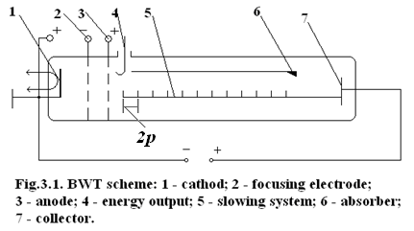

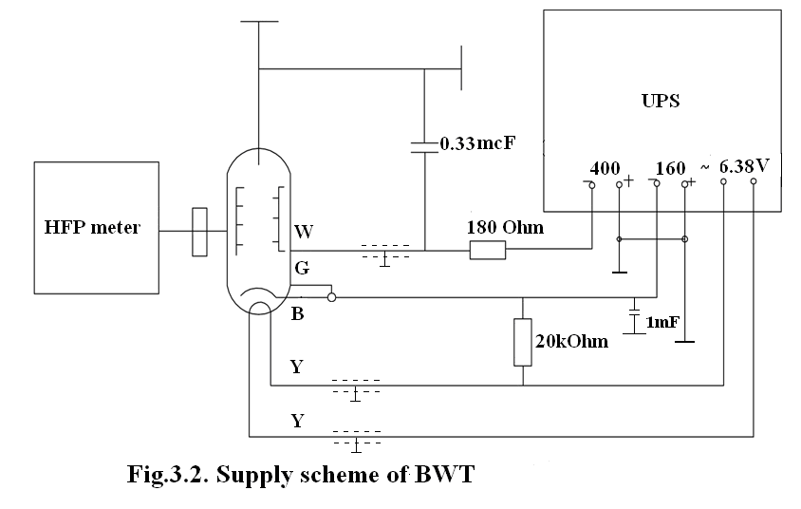

EMWs moving through the slowing system from point B to point A runs distance which is equal to *2p+2n*, and along BWT axis runs distance which is equal to system step *2p*. So, EMW velocity of transferring along BWT axis 𝜗 will be *Ks*-times less (*Ks* – is slowing factor). Because of EMW velocity 𝜗, in common case is equal to light velocity, we have:

$$ϑ=c·\frac{2p}{2h+2p}=\frac{c_{p}}{h+p}$$

There is an absorption element (6, fig. 3.1) near the collector is used for absorption of reflected wave from the end of wave slowing system.

In self-oscillated electron system must be performed next two conditions (amplitude, phase):

**1)** Electron beam moving to collector direction should give definite minimum of energy to the field, which is higher than self-losses level of this system.

Due to this, in every system we can observe necessity to provide definite value of electron current. Start current for BWT is equal to

$$I=\frac{0.124U_{0}}{R·N^{3}}$$

$U_{o}$– accelerating voltage that is applied to slowing system.

***R*** – coupling resistance, that shows interaction level between electron beam with EM field in slowing system.

***N*** – number of slowing wavelengths that are placed along slowing system.

From this dependence we can make conclusion about definite size of slowing system length on start current value.

**2)** In feedback circuit have to placed integer number of wavelengths, so only in this reason we will obtain positive feedback, i.e. phase coincidence of direct and backward waves.

The main peculiarity of BWT is inner feedback. It provided with the help of electron beam in any element of the slowing system.

In BWT, as in the klystron, we have velocity and density modulation, i.e. bunch making as result of electrons and field interaction and that bunch of electrons don`t leave slowing wave field. The best condition for energy transferring from field flux will be obtained. Thus, it is necessary that phase shift between bunch *Ф0* and wave don`t exceed:

$Ф_{0}=ω∙\frac{l}{U_{ph}}-ω∙\frac{l}{U_{0}}=π$, where

$ωl$**/ $U_{ph}$** – phase shift, which is created by backward space harmonic wave; $ωl$**/ $U_{0}$** – electron beam;

In BWT backward space harmonics have strong dependence on phase velocity or frequency due to accelerating voltage *U0* changing i.e. synchronizing condition in wide band frequency, which achieve several octaves. Wavelength dependence on accelerating voltage can be determined:

$$λ=2\left(h+p\right)+2p∙\frac{505}{\sqrt{U}}$$

Output power of BWT generator:

$P_{out}=K∙U_{0}(I_{0}-I_{0start})$, where

***K*** – coefficient, that depend on BWT gain parameters and electrical length of slowing system;

- start current, at which generation starts;

- beam current.

Start current value *I0start* is proportional to the voltage *U0*. So dependence *Pout* from *U0* is look like continuous curve. At first, output power is increasing, because of direct current increasing. $P_{o}=I_{0}U_{o}$, which is fed to BWT, but then due to start current increasing output power slows, comes down.

Power that fed the field with electron beam is small: from some tenth of miliwatts to some watts. Accordingly electron efficiency will be small too.

Work procedure

1. To study BWT work principle and draw power-supply circuit (Fig.3.1, 3.2).
2. Turn measurement device on and prepare it for the work, according to technical requirements.
3. Turn RWT power-supply on.
4. To find dependences $P=f(U_{o})$ and $f= f_{2}(U_{o})$ change accelerating voltage *U0* in range 250 – 400V with a 50V step. Put the results into a table 3.1.

Table 3.1

|  |  |  |  |  |
| --- | --- | --- | --- | --- |
| $$U_{0}, V$$ |  |  |  |  |
| $$P_{0}, W$$ |  |  |  |  |
| *f*, GHz |  |  |  |  |

1. To find dependence $f=φ(t)$ during 15 minutes (measurement interval is 5 minutes).

Report content

1. Test equipment scheme.
2. Measurements results.
3. Graphics, tables and calculations.
4. Conclusions.

Self-checking questions

1. What does electron beam in BWT interact with?
2. To which type of microwave devices we can refer BWT, with shot or long time interaction?
3. How does BWT energy move with respect to electron beam?
4. Draw the interaction between self-oscillating frequency and accelerating voltage.
5. Draw dispersion curve for traveling wave tube and BWT.
6. What is inner feedback?
7. What is the difference between BWT “O” (usual) and BWT “M” (magnetic) types?
8. List BWT applications.

**LABORATORY WORK #4**

**INVESTIGATION OF THE MAGNETRON GENERATOR**

**PURPOSE:**

1. To master practical skills of operating with the magnetron generator.
2. To study operation characteristics of the magnetron generator.

Short theoretical information

The magnetron belongs to crossed – field valves that differ from beam-type valves in several ways. The electrons are drawn from a cathode, but are in most cases largely intercepted by the collector or anode or resonant circuit as for example klystron. They give up energy to the circuit, but without slowing down, and they are formed into RF bunches but without necessarily increasing the space change. These are two aspects of behavior, which cause the limitation of power and efficiency in beam-type valves.

But there is another point of view to design microwave vacuum tube where these aspects are useful. In other words, the practical approach to resolve this problem is creation of conditions, when electrons flow in crossed of both electric and magnet fields or shortly cross – field.

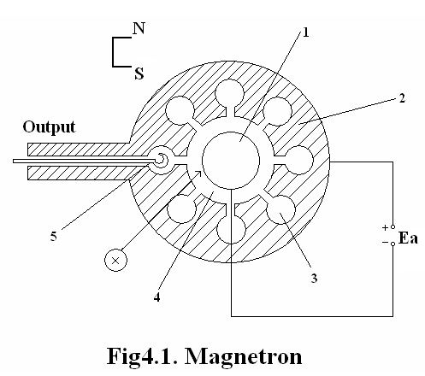Magnetron is used for generation of powerful oscillations in decimeter, centimeter and millimeter wave bands. It belongs to microwave devices with crossed electric and magnetic fields. Magnetron (Fig.4.1) consists of cylindrical cathode *1* and anode *2*, which is closed slowing system. Resonators are longitudinal cavities *3*, which are located in anode block and are connected by radial gaps with interaction space *4.* All resonators are connected by electric and magnetic coupling. Number of cavity resonators is even (from 4 to 40). For energy taking off, there is connection loop *5*.

Permanent magnetic field, which is directed along cathode axes is created by permanent magnet. Permanent radial electric field is created by anode voltage source ${ E}_{a}$, which is connected with the body **(**anode block) of magnetron and source minus is connected with cathode. Since the anode is a surface of the magnetron, as a rule it is earthed and the cathode is supplied with a high negative potential.

The magnetron operates with magnetic induction some more meaning that critical induction *Bcr.* Because of electrons are not contacted with anode and flow near internal surface of cavities. Since we have a large quantity of electrons with distinct start velocities, we can say that there is a ring-viewed electron cloud which rotates around the cathode. The presence of resonance systems calls the appearance of oscillations and an alternating electrical field.

This alternating electrical field can produce oscillations with different frequencies and phases. But we will see below that steady oscillations can take place. Of these the most important is that giving  phase change per cavity. In such sort of oscillations is shown in the resonance system. In this mode, the voltages on all the alternate segments rise and fall in phase together, and the state of charge, current and electric and magnetic field distribution throughout one cycle are shown diagrammatically. We must choose such direct both electrical and magnetic mode to obtain optimal interaction of electron with alternating electrical field, when the electron beam give the energy to the field. It’s just what is necessary to arise not realaxated oscillations.

In order to obtain  phase change per cavity inductive coupling must be very large. The structure of electromagnetic field is first of all concentrated between cavities, and behavior of electrons depends before all from scattering field. This field can be decomposed into two components, namely tangential  and radial .

Thus, the tangentional component of an electrical field carries out two functions: “sorts” the electrons, namely extracts “unfavorable” electrons and interacts with “favorable” ones and so RF field is provided by the energy. For explaining the radial component role.

Electrons move in the interaction space with the average velocity *=E/B* (figurative velocity of the cycloid center) The radial component of the electric field that we can find near the center of a gap is equal to zero. The direction of radial component coincide with anode constant field on the left and anode on the right. Therefore the electrons of group «b» are not subject to the radial component. The electrons of group “a” experience the combined field *E+Er* and their velocity increases. The same field produces the opposite effect an the electrons of group “c”, and their velocity decreases. As of electrons “a”, ”b”, ”c” bunch, so the role of the radial component is bunching the electrons.

Since we have alternating electrical field in any resonator of operation magnetron, electron cloud or charge is rotated and due to modulation of velocity and density, we have the deformation of electron charge into spoke-like form.

We can note that the number of “spoke” is two times less than the number of resonators. In order that the “spoke” might have gave maximum energy to RF field before all it must be -mode oscillations and time of the “spoke” passing the distance between two resonators is equal to half cycle of RF oscillations. Since the RF field of other resonator changes in every half cycle own direction the “spoke” will move in slowing field of gap because of their rotation. Thus we have synchronism conditions.

By far the majority of magnetrons are high-power pulsed valves, most frequently used as the RF power source in pulsed radar systems. They have many advantages: they are the smallest valves available for any given frequency and power, they are relatively cheap and, since they determine their own operating voltage, they can be run from fairly simple power supplies. They cannot, however, readily be modulated in phase or amplitude within the pulse, nor can their frequency be quickly altered. They have much poorer signal-to-noise ratios than beam amplifiers, and in general their lives are shorter than those of beam-power amplifiers. As a result, they are now tending to be displaced from the military field where cost is less important than performance and the need is to increase the sophisti­cation of performance, but will no doubt continue to be used for many years in civil systems, particularly in shipborne and airborne radar navigation aids, and for military applications where size and weight are all-important.

There are also c.w. magnetrons, which have particular applica­tions in the field of radio warfare and jamming systems, although in this junction they have been displaced by high-power crossed-field backward-wave oscillators. There is, however, one use for c.w. magnetrons which is steadily increasing, and 'his is for microwave cooking, where their cheapness, small size and simplicity make them the best choice. These produce power of 1 to 3 kW at about 2,450 GHz, which is directed into the food to be cooked or reheated. Be­cause the absorption of power takes place throughout the entire volume of the food, its temperature rises uniformly throughout, and joints of meat, for example, may be heated or cooked in minutes, which by the normal process of heating from the outside wouldtakehours.

Work procedure

1. Draw structural scheme of device for magnetron investigation (Fig.4.2)
2. Turn magnetron filament on 6.3V. After one minute turn voltage on 600V (voltage filament will decrease to 4.5 V)

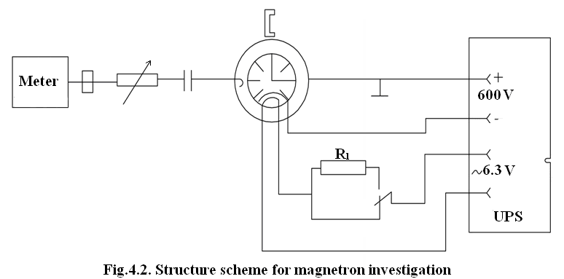

1. With the help of power measurement device determine existence of oscillations. Attenuators of device turn on maximum damping.

Note. Unlike to reflex klystron and BWT, which power is equal to tenths of miliwatts, investigated magnetron in continual regime has several watts power.

1. Measure power and frequency in order to measuring methodic, put results into the table 4.1.

Table 4.1

|  |  |  |  |  |
| --- | --- | --- | --- | --- |
| ***Ea*** | ***I*** | ***P0*** | ***f*** | ***η=P~/(EaIa0)*** |
|  |  |  |  |  |

1. Using table 4.1. construct operation characteristics: $P_{0}=f_{1}(I_{ao})$, $P_{\sim }=f_{2}(I_{ao})$, $f=f_{3}(I_{ao})$, $η=f_{4}\left(I_{ao}\right).$
2. Fix threshold voltage *Ea thr*, at which appear and break oscillations by decreasing of anode voltage *Ea*.
3. Find magnetron resistance by direct (static) and alternative (dynamic) current.
4. Calculate next parameters:

* Electron velocity between anode and cathode (under critical mode): $=6∙{10}^{7}\sqrt{E_{a}}$.
* Electron transit time between anode and cathode (accepted $l=0.3m$).
* Electron to light velocity ratio:
$$\frac{ϑ}{c}=\frac{\sqrt{E_{a}}}{300}$$

* Increasing of electron mass by Lorenz Formula:
$$\frac{m}{m_{0}}=\frac{1}{\sqrt{1-{\left(\frac{ϑ}{c}\right)}^{2}}}$$

* Intensity of permanent electric field between anode and cathode (if they are uniform):
$$E=\frac{E_{a}}{l}$$

* Electron transit time between gaps of neighbor resonators (with π-type oscillations):
$$t=\frac{T}{2}=\frac{0.5}{f}$$

* Average electron velocity in interaction field (between cathode and anode) :

$ϑ_{av}=E/B$, $B=0.4 Tl$

* Critical magnetic inductance:

$$B_{cr}=\frac{1}{l}∙\sqrt{\frac{2mE_{0}}{e}}=\frac{3.3∙{10}^{-6}\sqrt{E_{0}}}{em}$$

where e/m = $1.76∙{10}^{-11}$ K/kg, critical anode voltage, taking into account operation magnetic inductance $B=0.32 Tl$

$$E_{a cr}=\frac{et^{2}B^{2}}{2m}$$

* Electronic magnetron efficiency:
$$η_{e}=1-{\left(\frac{B_{cr}}{B}\right)}^{2}$$

* Oscillation efficiency of cavity resonator, which doesn`t depend on operation mode:
$$η_{cr}=\frac{η}{η_{e}}$$

* Accepting magnetron efficiency value in typical operation mode $η={P_{\sim }}/{P_{0}}$ and that $η=η_{e}η_{cr}$:
* Power obtained by cathode by unfavorable electrons:

$P=P_{0}-P_{nom}$,

Where $P_{0}$- power given by the source, when voltage filament is 4.5V; $P_{nom}$– nominal filament power.

Report Content

1. Purpose of the work.
2. Structural scheme of laboratory arrangement.
3. Results of measurements.
4. Graphs, tables.
5. Conclusions.

Self-checking Questions

1. On what frequencies bands magnetron can be used?
2. What powers pulse, magnetron can generate?
3. Describe magnetron construction.
4. How does anode block size influence on magnetron wavelength oscillations?
5. What electron trajectory that is moving in crossed electric and magnetic fields.
6. What is critical magnetron induction?
7. What is role of radial component of microwave field in magnetron?
8. Describe role of tangential component of microwave field of magnetron.
9. What are spokes? Name connection between number of resonators and spokes.
10. Explain synchronize conditions.
11. Calculate main magnetron applications.
12. Explain why does electron efficiency is connected with magnetic inductance?

**LABORATORY WORK #5**

**INVESTIGATION OF GENERATOR ON IMPATT DIODE**

**PURPOSE:**

To learn basic characteristics of the generators on impact ionization avalanche transit time (IMPATT) diode.

**THEORY**

Generator on IMPATT diode is close to semiconductor analog of electro-vacuum reflex klystron. Operation principle of IMPATT diode can be explained such way.

A suitable epitaxial sandwich of various doping layers can give a depletion layer of fixed width in a relatively weakly-doped region bounded by highly conductive end regions, if a reverse bias is applied. An example is nt-p-i-pt structure as shown in Fig. 5.1 a.

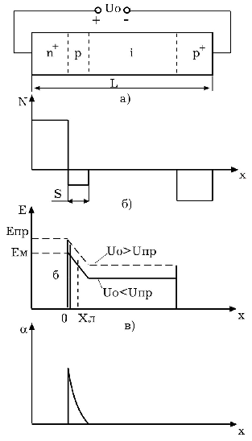

Fig 5.1 Structure of IMPATT diode and diagrams explained its properties.

The impurity distribution is shown in Fig. 5.1b. The bounder regions pt and nt are considerable more impurity doped than p-region and I-region is intrinsic semiconductor because of up to pt region charges does not change.

The ionization coefficient n-layer and p-layer will change more sharp forward axis X. For simplicity = =. The avalanche breakdown conditions means equality to unit the square outlined by curve (Fig. 5.1d)

The maximum field which occurs at the nt-p junction is of the order of several hundred kV/cm (Fig. 5.1c). When field density is more than v/cm we’ll have impact ionization in small part of locked layer that also called as multiplication layer. The electrons will move to the nt region, whereas the holes travel across the entire space-charge region to the pt layer. The field in the space-charge region is so high that carriers move with a field-independent velocity 𝜗. As result we have sharp increasing of the current through diode. The volt-ampere characteristic p-n junction is shown in Fig. 5.2. If besides constant voltage acts alternating oscillations we have as well as in the transistor operates with cut-off current the current pulses.

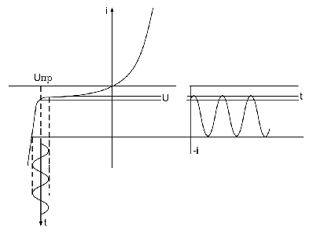

Fig. 5.2 Volt-ampere characteristic of p-n junction

Fig. 5.3 shows us distribution of field density under applied field to be oscillated. Doted line shows maximum and minimum meanings alternating field respectively.

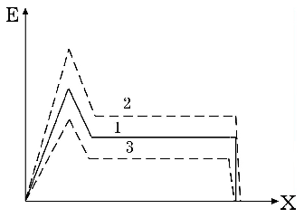

Fig. 5.3 Density field distribution under applied oscillated field.

For purpose of the amplification or oscillations microwave signal avalanche diode in work conditions switched on to the resonance system (Fig. 5.4)

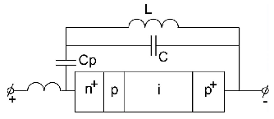

Fig. 5.4 Common avalanche diode circuit with resonance system.

Suppose that in resonance circuit there is already harmonic oscillations. In this case the common voltage of power supply and alternating voltage of resonance circuit (Fig. 3.10a).



Fig. 3.10 Time diagram of voltage (a) and currents (b) on avalanche diode.

The instantaneous alternating voltage periodically is above the constant voltage and is said the breakdown take start. As was discussed, avalanche current grows little by little. Consequently avalanche current delays on  relative in time of breakdown. The delay depends on value of electric field in avalanche layer. We can see that avalanche current pulse begins in time of high frequency voltage of resonance circuit change own sign. The pulse duration is characterized by transit time of electrons in drift space. The time delay determined the transit frequency





Thus in external circuit we have the sequence of induction current’s pulses delays relative breakdown voltage time. The pulses of induction current can be decomposed on Fourier series. In Fig. 3.10 b we can see that the first harmonic of these currents’ series is in opposite phase with alternating voltage of diode, therefore avalanche diode possess the negative resistance for external circuit. When this negative resistance has enough value, when all losses in circuit are compensated the not damped alternating oscillations take place.

In order to calculate IMPATT diode’s oscillator it is comfortable to represent it in view of equivalent circuit (Fig. 5.6).

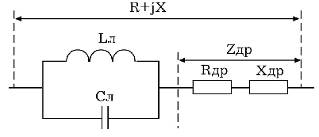

Fig. 5.6 Equivalent circuit of IMPATT diode in avalanche mode.

The parallel resonant circuit La, Ca represents multiplication layer. The total resistance of this layer is



where  - is avalanche frequency.

andreflects the processes in drift layer. The complete resistance of drift layer.



andare functions of transit angle 





where transit time in drift layer



The dependence from transit angle is shown in Fig. 5.7



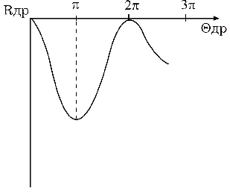

**Fig. 5.7** Dependence active resistance from



The maximum of negative resistance is observed near . We can see that value where it has negative resistance placed between , but .



Since when and m/sec then CHz

If I0 – is the average meaning of induction current, then amplitude value of induction current’s pulse is 2 I0, and the first harmonic accordance Fourier series is



The alternating power microwave oscillations in drift layer

,

where - the amplitude of sine voltage on drift layer.

In the rough estimate , then  and electron efficiency



The simple calculations that applied power is inverse proportional to square power of frequency



On more low frequency we have



At frequency 15 GHz output power more than 2W with 9% efficiency have been obtained. For pulse mode and wave length cm output power from 15 to 50 W with 10% efficiency have been obtained accordingly 5W and 7% in frequency band 33-36 GHz and 1W and 5% in frequency band 93-96 GHZ.

The simple design of avalanche diode oscillator is shown in Fig. 5.8. Oscillator contents coaxial cavity 1 which retuned with plunger 2 and avalanche diode placed in central conductor of cavity.

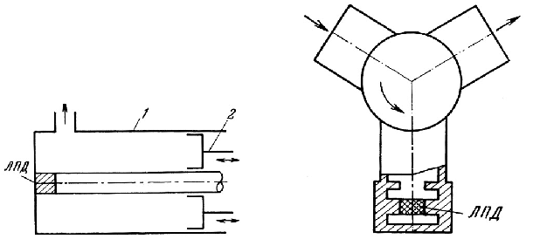 Fig. 5.8 IMPATT oscillator Fig. 5.9 IMPATT amplifier

The simply design of avalanche diode amplifier is shown in Fig. 5.9. The power source and load switched with two shoulders of circulator. With third shoulder is connected resonance system of diode. Amplification carry out when is connected resonance system of diode.

Home Task

1. Calculate IMPATT oscillation frequency in the circuit of coaxial resonator, size of which is determined by teacher. Value of p-n junction capacitance is 0.2pF.
2. To draw graph with dependence of oscillation frequency from location of tuning piston in the range of first zone of generator. Experimental functional setting is shown in Fig. 5.11.

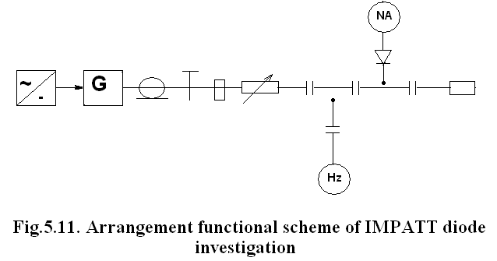

Investigated generator is tunable oscillator with IMPATT diode, which is installed in capacity gap. IMPATT diode fed from stabilized current source. Coaxial resonator output linked across attenuator with matched load and frequency meter.

Power oscillation measurement is performed with a help of detector head. Generator frequency tuning is executed by shift shortcut of resonator piston. For current and voltage measurement of power supply there are some measurement devices.

Work procedure

1. Acquaint with generator construction and measurement devices. Check circuit junction correction.
2. Turn on and heat device with accordance to instructions.
3. Tune, with a help of piston, operation mode of IMPATT on maximum output power.
4. Changing position of tune piston, take frequency and power dependences of generator within range of two adjacent generator zones.
5. Set mode of oscillations break, take VAC of IMPATT. Maximal current value mustn`t exceed limits of 1.5-times repeated operation nominal value.

Report Content

1. Draw structural circuit of set and IMPATT diode construction.
2. Draw the graph of VAC of unexcited IMPATT diode.
3. Write results of frequency and power measurements in generator IMPATT diode mode.
4. Compare obtained results with previous calculations.

Self-checking questions

1. Explain operation principle of IMPATT diode. Draw it`s VAC.
2. Explain operation principle of generator on IMPATT diode. Draw it`s equivalent circuit.
3. What methods of frequency tuning generator on IMPATT diode do you know?
4. Obtain formula of oscillations frequency of one-resonator generator on IMPATT diode.
5. What types of cavity resonators are used in generator on IMPATT diode?
6. Give general characteristics of microwave devices on IMPATT diode.

**LABORATORY WORK #6**

**IVESTIGATION OF THE MICROWAVE GENERATOR ON GUNN DIODE (GGD)**

PURPOSE:

1. To familiarize with operation principle of Gunn diode.
2. To familiarize with microwave construction of GGD.
3. To investigate operation of GGD.

THEORY

For some time, the most important application of the transferred electron effect seemed to be its use for oscillators. Then a formidable competitor appeared in the avalanche oscillator. Since, then a farther important field of devices emerged for the transferred electron effect namely its use for pulse generation and processing.

Gunn diode (GD) is excellent of transferred electron device (TED). The mechanism of the condition in GD is explained by transferred electrons in conduction band.

It so happens in GaAs in which Gunn discovered oscillations under pulsed conditions. Our further narration will touch the GaAs because of wide spread and studied material.

GD represents homogeneous semiconductor with ohmical contact and length L (Fig 6.1), which has donor impurity with charges concentration *Ne=1014 ...1016cm-3*



Fig 6.1. Gunn diode construction

In the space charge instability devices we use charges with negative differential mobility. For the first time it was GaAs for what differential mobility has been obtained.

The mobility of the free electrons depends on movement conditions in lattice (*lm* and *υm*)and naturally changes with different temperatures. Consequently mobility of carriers of the charge is different for difference semiconductor as well as for the electrons and the holes.

**Table 6.1**

|  |  |
| --- | --- |
| Material, carrier | Mobility m2/v sec |
| Ge, electrons | 0.36 |
| Ge, holes | 0.17 |
| Si, electrons | 0.15 |
| Si, holes | 0.04 |
| GaAs, electrons | 3.0 |

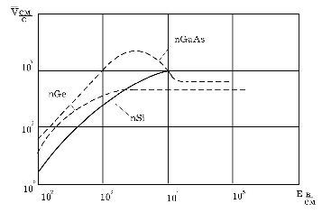

**Fig. 6.2** Electric field influence on electron drift speed.

The table 6.1 confirms the order of the curves located in Fig 6.2. As we can see in Fig 6.2 the curve for GaAs has fall part when $ε≤3.2∙{10}^{3}$*v/cm*when differential mobility $μ=∂υ/∂E$***<*** 0, and electrons can only occupy special energy levels. These levels can conveniently be expressed as a function of the momentum of the electrons. If this is done for energy levels of the conduction electrons, the conduction band, we find some structure such as that of Fig 6.3 which shows the energy contours of the GaAs conduction band. It so happens in GaAs that we find the lowest valley in the centre of the Brillouin zone and three side valleys in the directions.

**Fig 6.3.** Energy contours of GaAs in reduced zone (E=energy; VB = valence band; CV = central valley; SV = satellite valley)

Effective mass of electrons. It is known, that electrons in "solids" are influenced by very strong periodical electric field of lattice.

The influence of crystal lattice field we can represent by the help of effective mass of electron *meff.*

The conception of effective mass is sufficient by conventional and it is used only for comfortable description the moving of electrons in "solids". When periodical electric field is absent *meff* =m0. In common case the magnitude *meff* can differ from mo and can have as positive meaning as well as negative one.

The energy minimum at the centre of the Brillouin zone moves up in energy, the electrons in this valley obtain a higher effective mass and electron transfer to the higher-lying satellite valleys occurs for lower electron temperature or, in other words, for smaller applied electric fields. In fact an increasing pressure results in a decrease of the threshold field for the transferred-electron effect and if the applied pressure is large enough, no Gunn oscillation can occur.

The energy difference ∆= 0.38 ev for GaAs and the carrier properties in the two types of valley are given in Table 6.2

Table 6.2

|  |  |
| --- | --- |
| Effective mass | Mobility |
| centre valley m = 0.07 m0  satellite valley m = 0.4 m0 | ~7500 sm2/v·sec  ~200 sm2/v·sec |

Here m0 - free electron mass.

If there is no drift field applied at the GaAs crystal, the carriers will be on the bottom of the central valley. For a given drift field, the carrier gains energy and move up to higher energy levels. If they have gained more energy than ∆= 0.38 ev, they will cross over to the satellite valley, caused by inter-valley scattering. Owing to this transfer mechanism, this theory is called "transferred electron theory".

According to Boltzmann's law the electron's concentrations *N2*and *N1* on energy levels***2*** and***1*** (Fig 6.3b).



where  - isconstant of number of the permitted energy levels. When room temperature takes place; (**2**-**1**)=0.38 ev and kT=1/40 ev, we geti·e. actually all electrons take place in central valley.

The drift velocity as aq function of field must then have a behavior as shown in Fig 6.4.



**Fig 6.4.** Characteristic of drift velocity vs. Field of transferred electron effect

When electric fields larger than 3000 v/sm we have Gunn effect. Let consider the Fig 6.5



**Fig 6.5.** Gunn`s diode model: a) the field of domain origin ∆x;

b) the distribution of the electrons concentration;

c) the distribution of the electric field E(x) in the dipole domain

Suppose then, that there is a fluctuation of the charge density in section *∆x* (from point *x1* to the point *x2).* Then, the field intensity of the pattern with length L has critical value *Ecr= υ0/L,* we can see in Fig 6.5 the more of the electrical field intensity, the less velocity of electrons in section *∆x* where $∆υ_{2}=\left|μ_{12}\right|∆E_{2}$*.* Since difference of potential on the pattern remains constant it must observe the condition

$∆x∙∆E_{2}=\left(L-∆x\right)∆E_{1}$,

where ${∆E}_{1}$- is decreasing of the field intensity in ohm's part of the matter, with length $(L - ∆x)$. As we can see decreasing value of field on AEi leads to decreasing electrons velocity in ohm's part on $∆υ_{1}$. Thus, accidental fluctuation of the charge will call braking the electrons in the NDM part on value $∆υ_{2}=\left|μ_{12}\right|∆E_{2}$ and also in the ohm's part on value $∆υ_{1}=μ_{1}∆E_{1}$ where we have

$$\frac{∆υ_{2}}{∆υ_{1}}=\frac{\left|μ_{12}\right|∆E_{2}}{μ_{1}∆E_{1}}=\frac{\left|μ_{12}\right|}{μ_{1}}=\frac{L - ∆x}{∆x}$$

Transit time $t_{tr}$ is many times more than domain's forming time, therefore we can not build classic dynamical characteristic for known load *RL.* In domain mode GD operates as a current switcher. When *I=I1*,the current "jumps" from value *I1* to *I2,* and after transit time again takes place meaning *I1*. Therefore VAC of GD in domain mode we can present it as a broken line ABCD (Fig 6.6)



Fig 6.6. Volt-ampere characteristic of Gunn diode

If considered triangular pulses output is fed into a resonant circuit (Fig 6.7) with a high enough Q-factor, then resonant circuit “cut-off” narrow band



**Fig 6.7.** Fundamental transit-time mode:

*a* - external circuit of Gunn diode; *b* ***-*** the voltage shape on GD; *c* - the current pulses shape

frequency that contains the triangular pulses and we obtain the “fundamental transit-time mode” if the circuit-resonance frequency isthe same as the transit-time frequency. The efficiency is low, as the frequency spectrum of the current contains little energy at the fundamental frequency.

On the other hand, if the circuit-resonance frequency *f0* is tuned to same harmonic of the transit-time pulses we obtain the harmonic transit-time modes. One can describe this also as follows: it *f0* is the nth harmonic of the transit time frequency, the output voltage will have a waveform consisting of a series of damped sinusoids, reinforced every nth cycle. The diode, however, has during domain transit internal impedance whose real part can be negative, so that the amplitudes of the output voltage can also remain constant or even grow between the domain-pulses. When the domain arrives at the anode, the diode present a different impedance, whose real part might then cause a corresponding decrease in oscillation amplitude gain. This mode of oscillation can, therefore have either various amplitude fluctuations or constant-amplitude oscillations. If the resonance voltage is large enough, so that it can influence the domain nucleation and extinction we have the so-called resonant modes.

Negative resistance. Let us consider the circuit (Fig 6.7).The fundamental transit-time mode is determined by nonequality

$$U_{d}≤(U_{0}-U_{re}).$$

If *Q*-factor $Q≤5$ one can consider that both voltage form resonance circuit and current form across RL look like harmonic. As it goes from Fig 4.9 the maximal power contribution to resonance circuit will be done when resonance frequency f0 is equal to transit-time frequency $f_{0}=f_{tr}=1/τ_{tr}$ i.e. $Lf_{tr}=υ_{tr}≈{10}^{7}$ sm/sec. In this case the phase lift between voltage on GD and first harmonic of current is equal to 180° and equivalent of active negative resistance.

PROCEDURE

1. After learning theory and laboratory set of GGD. Turn power measurement device on, calibrate it, set maximum feeding of Gunn diode and turn generator feeding on.
2. Measure oscillation power of generator dependence on feeding voltage $: P_{1}=f(E_{d})$. Feeding voltage must be changed from 3 to 8V, by $I_{d}$ value fixing. Measure frequency under next voltage values ${ E}_{dmin},E_{dav}, E_{dmax}$.
3. Draw dependence $P_{1}=f\left(E_{d}\right)$ and determine linear part on the characteristic. Find $E_{dav}$, that correspond to the middle of linear part and determine amplitude of modulating voltage $U_{Ω}$.
4. Execute next steps: set $E_{dav}$, turn modulator on, then set $U_{Ω}$, which is equal to calculated value. Observe the form of modulating signal both on modulator output and detector input with the help of oscilloscope.
5. Investigate microwave generator operation in pulse mode. Set $E_{d1}<E_{dmin}$, then in accordance to the next condition $U_{min}=E_{dmax}-E_{dmin}$ choose amplitude of modulating pulse. Pulse duration must be equal to 2μsec. Observe generator output pulse form and determine its parameters (*τf*, *τd*).
6. Determine frequency stability of microwave generator. Perform counts every two minutes.

Report content

1. Electric circuit of investigated GGD.
2. Tables and graphs, made accordingly to experimental data.
3. Conclusions.

Self-checking questions

1. Explain Gunn diode operation principle.
2. What operation modes, parameters and peculiarities of GGD do you know?
3. What peculiarities of GGD construction do you know?
4. What is VAC of Gunn diode?
5. List peculiarities of Gunn diode operation in oscillation amplification mode.

**LABORATORY WORK #7**

**ALIGNMENT OF THE HELIUM-NEON LASER**

**PURPOSE:**

1. To familiarize with construction of gas laser.
2. To learn alignment technique of optical-quant generators.

THEORY

A gas laser consists of quartz or ryrex tube filled with an active medium – a suitable gas or mixture of gases at a sufficiently low pressure. During pumping, ion discharge takes place. Coaxial with the tube-inside or outside according to the design – mirrors are placed, which, together with the contents of the discharge tube, from the resonant cavity. The excitation of the system, i.e. the transfer of the atoms or the molecules of the gas into an excited state is due to an electric discharge in the tube usually a high frequency discharge without electrodes, but also produced by means of a d.c. or short pulses. Because of the low amplification per length unit of the active medium of a gas laser, the length of the tube is large – 80cm, and a diameter - of about 1,5cm.

In accordance with energy level system and general statement design of He - Ne laser must subordinate to the block scheme shown in Fig.7.1.We can see the consequence of gas laser operation. First of all, pumping system (in our case we may have either direct current or high



Fig.7.1. Block - scheme of gas laser

frequency generator) that creates electrical field in discharge plasma and electrons are born by means of which He atoms become exitated and, than pass high level and in their turn they excite Ne atoms. Transitions of Ne atoms from high level to low one produce laser beam.

There are two essentially different designs for laser: the original conception with mirrors placed within the tube containing the low pressure gas and the later construction where the mirrors are placed outside the tube and the tube is sealed by Brewster windows. Both designs have their advantages and disadvantages and both of them are used.

The design with mirrors placed outside Fig.7.2 makes use of the fact that there is a certain angle , the so - called Brewster angle, for which the incident beam is totally reflected in one polarization whereas in the other polarization it passes through a plane parallel glass radiation

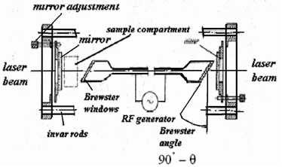

Fig.7.2. Design of a gas laser

the electric vector of which is lying in the plane of the sketch passes through the transverse windows of the discharge tube. The radiation with a vector perpendicular to this plane is totally reflected by the window. As the emission of gas laser is already linearly polarized - for low outputs even to a large extent - the transverse windows at the Brewster angle do not lead to a decrease in the output of the laser but only cause a rotation of the plane of polarization of the emitter radiation into the plane shown in Fig.7.2.

*The mirrors of the Fabry - Perot* interferometers are a very exacting optical task. As a rule, they are made from fused quartz with a minimum of stress, they are ground and polished to a tolerance in flatness of less than 1\20 of one wavelength and, in some cases, higher claims have even been made of a tolerance of less than 1\50 λ. The average imperfections of mirrors having tolerances up to 1\50 λ lead to losses of 1% in the cavity, for tolerances up to 1\20 λ the losses increase to 5%, a value already almost inadmissible for a gas laser.

The reflecting layer can be either silver with a maximum reflectivity of 97 to 98%.

The group of active media formed by the more common elements and molecules is also rather large. We shall examine the inert gases in the first place. A standard active medium for a gas laser is a mixture of neon and helium. The operation of a gas laser is based on the interaction of atoms of two gases that are in close energy levels. As can be seen from the energy diagram shown in Fig. 7.3 the level 2³s of helium lies close to the level 2s of neon, which consists of four sub-levels.

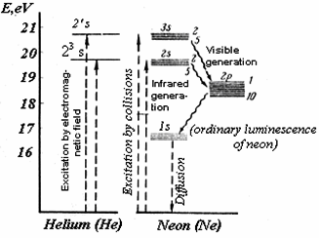

Fig.7.3. Energy levels of helium and neon

The atoms of helium are excited by the gas discharge and pass to the upper level 2³s. Taking into account inelastic collisions between the atoms of the two gases, the excited atoms of helium give off their energy to the atoms of neon, so that the latter rise to one of the four metastable levels 2s.

When the population of the neon level 2s becomes sufficient, an induced coherent radiation corresponding to the transition to the level 2p sets on. The neon atoms then return to their ground state. The neon level 2p consists of 10 sub-levels. The total number of possible transitions corresponding to different lengths of the radiated waves is 16, all of them lying in the near infrared region within 0,94µ to 1,5µ. By now, generation has been obtained on five waves, the best results in terms of intensity being for the wavelength of 1,15. Recently generation in the visible region at 6,3µ was produced. Optical transitions here are due to an emission of photons between the 2s - levels of neon and the 2p- levels of neon. These transitions satisfy two basic conditions necessary for the generation of light by stimulated emission: excitation to one of the higher energy levels is preferred and the lower energy level is more rapidly emptied.

We are often interested in emission in the visible region. With inert gas it was obtained for the first time with neon in He- Ne laser. This is due to the fact that the excitation of helium by means of high frequency field leads - besides the formation of certain concentration of atoms in 2`s state - to a smaller concentration of atoms in the 2`s state, a singlet metastable helium level. This singlet level lies on the energy scale rather close to the 3s level of neon so that the transfer of excitation energy, 2`s (He) →3s (Ne) leads to an inversion between the 3s - and the 2p - state of neon. The stimulated emission obtained lies in the red region, the most intense line being at  = 6,328µ.

Helium-neon lasers have high radiation coherence on not so high power up to 100 mW with low efficiency (close to 0.1%). Main application domain of helium-neon lasers are measurement technique, scientific researches. Accuracy of alignmentinfluences on energetic, spectrum and other parameters of radiation.

For spherical non-focal resonator (Fig.7.3) critical alignmentangle is equal to:

$$β=\frac{α-r}{χL}$$

where $α$– active element radius,

$$r=\sqrt{\frac{R_{d}λ}{2π}(1+{(\frac{l}{R_{k}})}^{2})}$$

Where $l$- active element length.

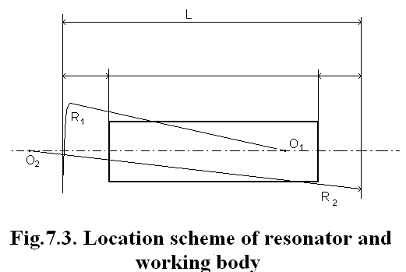

$$R_{k}=2L\frac{\sqrt{q_{1}q_{2}(1-q_{1}q_{2})}}{q_{1}+q_{2}-2q_{1}q_{2}}$$

$q_{1}=1-\frac{L}{R_{1}}$; $q_{2}=1-\frac{L}{R_{2}}$, if $q_{1}=q_{2}=q$, than $R_{k}=L\sqrt{\frac{1+q}{1-q}}$;

$X=\left\{\begin{aligned}\frac{1-l_{2}/R_{k}}{1-R_{1}/R_{k}} \\ \frac{q_{2}-l_{1}/R_{k}}{1-q_{1}q_{2}}\end{aligned}\right.$ bigger of two values is taken.

- distance from active element butts to appropriate resonator mirrors.

Working procedure

1. To familiarize with construction of helium-neon laser of next type ЛГ-56 or ЛГ-36А.
2. To calculate value of critical unalignmentangle of helium-neon laser ($λ=0.6328 μm$), with taking into consideration constructive parameters, given at *add1*, tabl.2.5.
3. Align laser of ЛГ-36А type with a help of autocollimator. To do this we need take front resonator mirror and active element tube with a gas off; combine images of autocollimation mark from back mirror by series installation of active body with other resonator element and output mirror; active element must be centered and correctly oriented on resonator axes. When alignment is correct, generation appears.
4. Alignlaser of ЛГ-56 type with a help of dioptric tube. For low-power helium-neon lasers with semiconfocal cavity resonator this method is widely used. Observation must be executed during burning of dischargethrough output mirror with light filterusing. Sequence of operation is next:

* turn laser ЛГ-56 feeding on and set discharge current equal to 10…12mA;
* take front and back bushingsof;
* observing from front mirror side, to combine images of eye apple with the centre of active element tube. To do this by founding of back tube end, with the help ofalignedscrews, combine images of eye apple with back tube end;
* execute analogical operation with a help of back mirror;
* put dioptric tube to laser head from output mirror side. Focus it on the back mirror. With a help of back mirror alignedscrews, do bright light spot in a centre, rounded by black ring, and then light background again. brightness of spot must be easily changed by alignedscrews. If there something troubles with this, repeat p.4.
* transfer focusing on front mirror. By this, we can observe interferential rings, that is character for Fabri-Pero interferometers.
* With the help of alignmentscrew to set front mirror in a that way, so spot that lights, comes into the centre of concentric rings. Next changing’s we must execute by observations of beam on the screen.
* If generation does not execute, it is recommended to brush window of active element with the cotton wool that is wet on alcohol**,**  and then – to take dust off.
* To change discharge current: increase or decrease it.

Caution! By alignmentwith a help of autocollimator, when it is needed to change front mirror and active element, all operations must be executed with a help of teacher.

By alignmentof dioptric tube it is necessaryto remember, that it is strictly forbidden to see on straight or reflected laser beam without glasses with light filter**,** thus in every moment generation can appeared. Alignmentby turning of light filter discharge is strictly forbidden **!** All operations must be executed with the help of teacher.

Report Content

1. Construction drawing of helium-neon laser.
2. Equipment components and sequence of unalignmentoperations.
3. Calculation of critical unalignment angle.
4. Conclusions.

Self-checking questions

1. Name main components of laser construction.
2. What is instantaneousradiation?
3. What is inductive radiation?
4. What does radiation frequency of quant generator defines?
5. What is open resonator? Name its peculiarities.
6. Name main parameters of quant generator.
7. What is distinction between one-mode and multimode work of quant generator?

**Main parameters of pulse generators MCDT ГИ-25 and ГИ-31**

|  |  |  |  |  |  |  |  |  |  |  |  |  |  |  |
| --- | --- | --- | --- | --- | --- | --- | --- | --- | --- | --- | --- | --- | --- | --- |
| **Type** | **Parameters** | | | | | | | | | | | | | |
| $$P_{p},$$ $$W$$ | *S,*  *V* | $$U_{l},$$ $$V$$ | $$I_{l},$$ $$A$$ | $$E_{d},$$ $$V$$ | $$I_{a},$$ $$A$$ | $$I_{c},$$ $$A$$ | $$E_{a},$$ $$kV$$ | $$P_{a},$$ $$W$$ | $$P_{c},$$ $$W$$ | *C,kV $$q_{min}$$* | $$C_{in},$$ $$pF$$ | $$C_{var},$$ $$pF$$ | **hr** |
| ГИ-25 | $$≥700$$ $$≥1500$$ | 24 $$≥15$$ | 6,3  6,3 | 0,95  0,95 | -2,5  -2,5 | 2,8  2,5 | 0,7  2 | 31  2,8 | 12  10 | 0,25  0,5 | 800  400 | 4,5 $$≤5$$ | 2,5 $$≤0,04$$ | $$≥250$$ $$≥2000$$ |
| ГИ-31 |

**Some data’s for reflex klystrons**

|  |  |  |  |  |  |  |  |  |
| --- | --- | --- | --- | --- | --- | --- | --- | --- |
| **Type** | **Parameters** | | | | | | | |
| $$α, sm$$ | $$E_{p}, V$$ | $$I_{o}, mA$$ | $$E_{ref, } V$$ | $$P_{\sim }, mW$$ | $$Δf, MHz$$ | $$l_{p}, mm$$ | $$l, mm$$ |
| K-19 | 3.15 | 500 | 30 | - | - | - | - | - |
| K-20 | 3.27 |  |  |  |  |  |  |  |
| 3.13 | 300 | 30 | - | - | - | - | - |
| K-20 | 3.5 |  |  |  |  |  |  |  |
| K-27 | 3.1 | 300 | 20 | 90 | 20 | 70 | 0.25 | 24 |
| 3.53 |  |  | 200 |  |  |  |  |

**Some data’s for magnetrons**

|  |  |  |  |  |  |  |  |  |  |  |
| --- | --- | --- | --- | --- | --- | --- | --- | --- | --- | --- |
| **Par**  **Type** | $$P_{\sim }$$ | $$f_{r},$$ $$MHz$$ | $$I_{nor},$$ $$mA$$ | $$I_{a0},$$ $$mA$$ | $$E_{a},$$ $$V$$ | *SWC* | *B,*  *T* | *U,*  *V* | *q* | $$τ,$$ $$mksec$$ |
| M-657  (cont. mode) | 7.5 W | 9350-9390 | 70 | 75…85 | 600  576…630 | 1.5 | 0.3 | 6.3  4.5 | - | - |
| МИ-268  (pulse mode) | 16…25 kW | 9377-9373 | - | 6.5…8.6 | 7000-7500 | 1.1 | - | 6.3  4.5 | 600 | 0.5…4 |

**Main technical parameters of BWT OBC-5 type**

|  |  |
| --- | --- |
| **Parameter** | **Parameter value** |
| Output power $P_{out}$, mW  Operation range frequency $f_{w}$, MHz  Control voltage $U_{c}$, *V*  Negative cathode voltage *U, V*  Cathode current $I_{c}$, *mA*  Negative close voltage $U_{n}, V$ Filament current $U_{f}, V$ Filament current $I_{f}, mA$ Control electrode current $I_{e}, mA$ SWC (standing wave coefcicient) | $$≥90$$ 9090….9617  250…450  160  15…45  50  6.5  0.6  25  1.2 |

**Resonator parameters, that are used in helium-neon lasers**

|  |  |  |  |  |  |
| --- | --- | --- | --- | --- | --- |
| **Laser** | $$L, m$$ | $$l, m$$ | $$R_{1}, m$$ | $$R_{2}, m$$ | $$α, cm$$ |
| ЛГ-36  ЛГ-56  ЛГ-75 | 1,5  0,3  1 | 1,2  0,25  0,96 | 10  1  2 | $$∞$$ $$∞$$ $$∞$$ | 0,5  0,1  0,5 |